**Share Folder IS Not Access**

**Error**

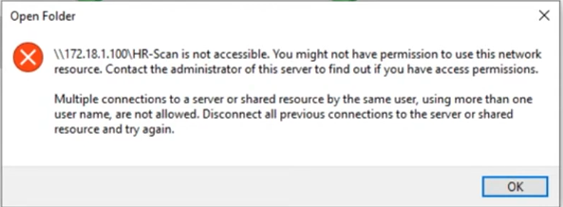

**Solution:**

(Open Command Promt)-Run As Administrator

C:\Windows\system32**>** net stop workstation /y

C:\Windows\system32**>** net start workstation

**If same problem is here then**

1. Going to services (just search services on searchbar).
2. Go to server and restart.
3. Go to workstation and restart.